Case Study  
  
Following points explain the appointment system in a hospital.  
  
Patient will have attributes such as name, age, etc.  
A patient can consult multiple doctors and vice-versa.  
A patient can have multiple appointments with doctors.  
Doctors also will have access to their appointments with patients.  
An appointment will have the details such as date & time, consulting doctor, patient, etc.  
While fixing the appointment  
Doctor's consultation duration is 1hr  
Doctor's consultation time will be between 8am - 4pm  
  
Q1  
  
Identify the entities & relations. Load the given CSV data into the objects

Database Schema

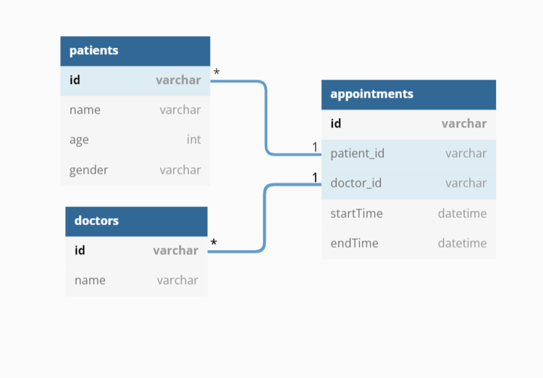  
  
Q2  
  
Get all appointments for the given doctor & date  
  
Q3  
  
Fix appointment by patient, doctor and date & time  
  
Q4  
  
Cancel appointment by patient, doctor and date & time

Note:

State any assumptions made.  
  
Dummy CSV  
  
doctor_id, doctor_name, patient_id, patient_name, patient_age, patient_gender, appointment_id, appointment_datetime  
D1, D1Name, P1, P1Name, 12, M, A1, 08032018 09:00:00  
D1, D1Name, P1, P1Name, 12, M, A2, 08042018 10:00:00  
D1, D1Name, P2, P2Name, 22, F, A3, 08032018 10:00:00  
D1, D1Name, P1, P1Name, 12, M, A4, 08042018 11:00:00  
D2, D2Name, P1, P1Name, 12, M, A5, 18032018 08:00:00  
D2, D2Name, P1, P1Name, 12, M, A6, 18042018 09:00:00  
D2, D2Name, P3, P3Name, 32, M, A7, 18032018 09:00:00  
D2, D2Name, P3, P3Name, 32, M, A8, 18042018 10:00:00  
  
** The solution can be in any language and what is expected is the source code and instructions to run the solution. Candidates can share the solution in different ways eg github repository link where all files are kept or zipped file (with source code & instructions) placed in a shared google drive.